**PROJECT SYNOPSIS REPORT**

**ON**

**FINANCIAL ANALYSIS CALCULATOR**

**SUBMITTED**

**TO DR. Suhasini**

**DEPARTMENT OF COMPUTER SCIENCE AND ENGINEERING**

**FOR**

**INTEGRATED PROJECT (CS203)**

**Submitted By: G-5**

**Names:**

**1. AGRIM CHAUDHARY**

**2. AMARBIR SINGH**

**3. ADITYA KAPOOR**

**4. AMAN DHAMIJA**

**University Roll No(s): (A) 2110990106 (B) 2110990159 (C) 2110990092 (D) 2110990147**

**Semester: 6TH SEM**

**Session:2021-25**

# **Index**

|  |  |  |
| --- | --- | --- |
| **Sr. no** | **Topic** |  |
| 1 | Problem Statement |  |
| 2 | Title of project |  |
| 3 | Objective & Key Learning’s |  |
| 4 | Options available to execute the project |  |
| 5 | Advantages/ Disadvantages |  |
| 6 | References |  |

# **Problem Statement**

Individuals often lack readily accessible and user-friendly tools to perform essential financial calculations. Traditional financial calculators can be cumbersome and limited in scope, while existing online options may be scattered, complex, or lack specific functionalities.

To develop a comprehensive financial calculator website that offers a **centralized platform** for users to perform various financial calculations, catering to individuals of all financial backgrounds and goals.

Title of our project **FisCalc™**

* Loan Calculators: For mortgage, car loans, personal loans, etc.
* Investment Calculators: Compound interest, return on investment, retirement planning.
* Budgeting Tools: Expense tracking, income vs. expenses, savings goals.
* Currency Converters: Useful for international travelers or investors.
* Tax Estimators: Help users estimate their tax liability.
* Savings Calculators: Calculate future savings based on regular contributions.
* Debt Payoff Calculators: Strategies for paying off credit cards, student loans, etc.

**Objective & Key Learnings**

* Individuals seeking to manage personal finances, including budgeting, saving, and debt management.
* Individuals planning for retirement, estimating future needs, and exploring retirement savings options.
* Loan calculators: Calculate monthly payments, total interest paid, and loan comparison for various loan types (e.g., mortgage, auto, personal).
* Investment calculators: Calculate potential returns, compound interest, and future investment values.

**Options Available to Execute Project**

* **Microsoft Excel:** Excel boasts a vast library of pre-programmed functions specifically designed for financial calculations.
  + Loan & Mortgage Calculations: PMT (payment), RATE (interest rate), PV (present value), FV (future value) - help with loan comparisons, EMI calculations, and future investment values.
  + Investment Analysis: IRR (internal rate of return), XNPV (net present value) - used to assess investment viability and profitability.
  + Depreciation Calculations: SLN (straight-line depreciation), SYD (sum-of-years' digits depreciation) - help track asset value over time for accounting purposes.

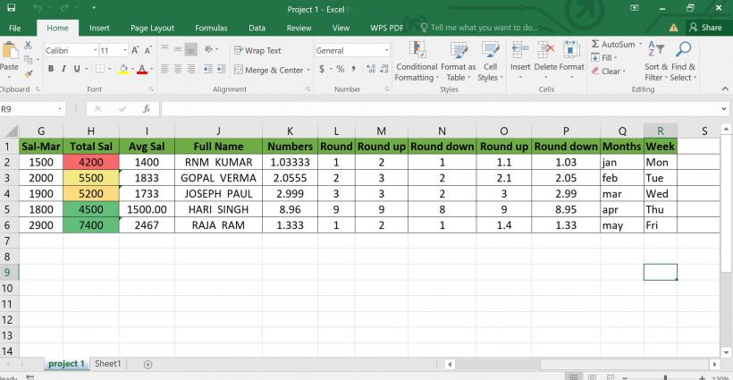

* **MySQL**: MySQL enables storage and retrieval of website content, making it easy for users to manage and update their website's information.
  + MySQL excels at storing data in a structured format using tables and columns. This allows you to organize financial information like transaction details, account balances, and investment holdings in a clear and organized manner.
  + Security Features: MySQL offers various security features to protect sensitive financial data. You can implement user access controls, data encryption, and audit trails to ensure only authorized users can access information and track any modifications.
  + Scalability: As your website grows and the amount of financial data increases, MySQL can scale efficiently.

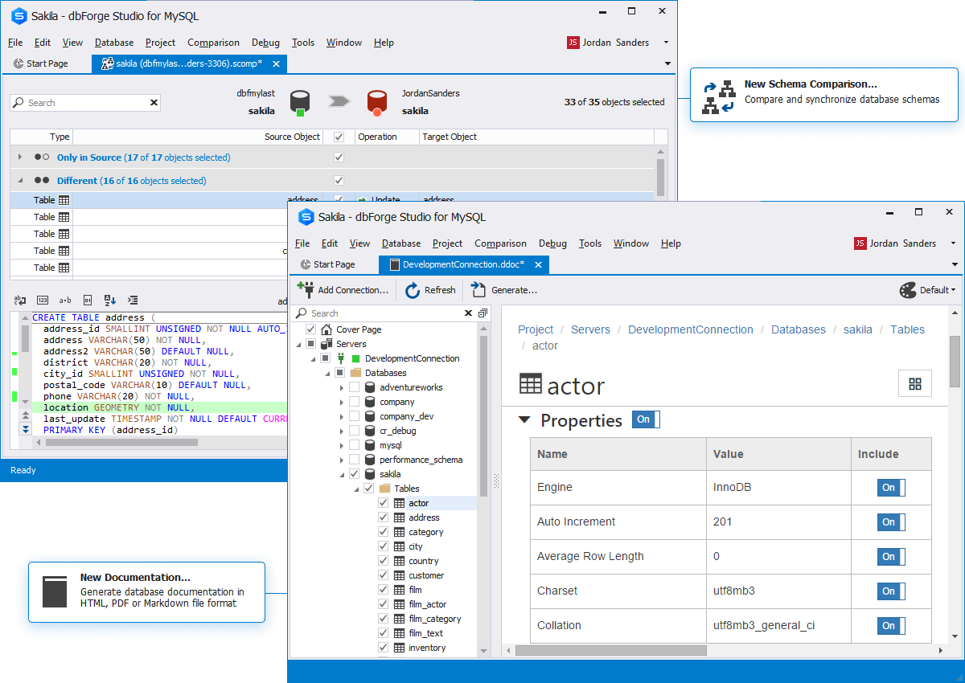

* **React JS:** React JS will be used in the development of our website in the following ways.
  + Interactive Components:React allows creating reusable components with encapsulated state and logic. Each component can handle user input, perform calculations, and update its display independently, creating a dynamic and interactive user experience.
  + State Management: React provides efficient ways to manage the state of the calculator, such as using the use State hook. This allows the calculator to keep track of user-entered values, intermediate results, and final calculations
  + Complex Calculations: React doesn't directly perform calculations; it handles the UI and state management. However, it effectively integrates with JavaScript libraries like mathjs or custom functions to handle complex financial calculations.

# **Advantages**

* **Accessibility and Convenience:** A financial calculator website is accessible from any device with an internet connection, 24/7. This eliminates the need for users to download or install software, allowing for quick and easy access to financial calculations whenever needed.
* **Variety of Calculators:** A single website can offer a wide range of financial calculators, covering various aspects like loans, mortgages, retirement planning, investments, and more. This saves users time and effort searching for individual calculators for different needs, providing a one-stop shop for various financial calculations.
* **Reduced Errors:** Financial calculations can be complex and prone to errors when done manually. A financial calculator website automates the calculations, minimizing the risk of mistakes and ensuring accurate results based on the user's input.
* **Enhanced User Experience:** Financial calculator websites can offer user-friendly interfaces with clear instructions and step-by-step guidance. This makes them easy to use for individuals of all technical backgrounds, improving the overall user experience and making financial planning more accessible.

# **Disadvantages**

* **Reliance on accurate user input:**  Inaccurate input leads to misleading results.
* **Limited to built-in formulas:** May not handle complex, user-specific scenarios requiring unique calculations.
* **Potential for internet connectivity issues:** Offline access often unavailable, hindering usability without a stable connection.
* **Security concerns:** Entering sensitive financial information online carries inherent risks, requiring careful website selection and data security practices.

# **References**

* [Home | Income Tax Department](https://www.incometax.gov.in/iec/foportal/)
* [Free Online Spreadsheet Software: Excel | Microsoft 365](https://www.microsoft.com/en-in/microsoft-365/excel)
* [W3Schools Online Web Tutorials](https://www.w3schools.com/)
* [Investopedia](https://www.investopedia.com/)